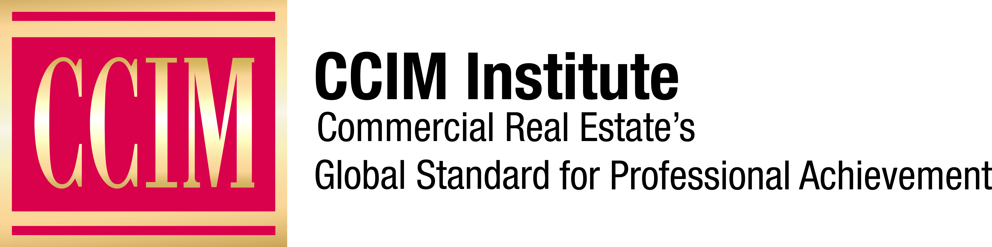

Contact: [Name of Contact] at [Phone number] or [email address]

[Headline]

[City], [Date] – [Write the news release here. Include one or more quotations from CCIM chapter members about the event or person being covered.]

CCIM Institute is a global community of 13,000 members, more than 50 chapters, and 30 countries that educates and connects the world’s leading experts in investment strategy, financial analysis, and market analysis.

Learn more about CCIM Institute’s education and designation program at ccim.com.

###

About CCIM Institute
CCIM Institute created the language of global real estate investment. Our courses and worldwide community deploy commercial real estate investment methodologies and tools that speed the pathway between opportunity, a go/no-go decision and success for an asset, taught by instructors who are themselves industry leaders. Today, the organization, through its 50 chapters, continues to innovate best practices and elevate the commercial real estate professional through its core designation program to earn the CCIM pin— real estate’s most coveted credential — and its topical education courses offered through the Ward Center for Real Estate Studies. In addition, membership in CCIM includes the industry’s best technology and operational platform, allowing entrepreneurial and mid-sized businesses to compete with the largest multinational providers. Today, almost 70 percent of designees hold the title of owner, partner, principal, or president, representing an exclusive worldwide referral network of 13,000 members in 30 countries. Ultimately, CCIM represents a larger vision of the commercial real estate provider, leveraging investment analysis, opinions of value, and underwriting to become a leader in sourcing capital, building a cash-flow vehicle, and ultimately creating value. Information at www.ccim.com.

