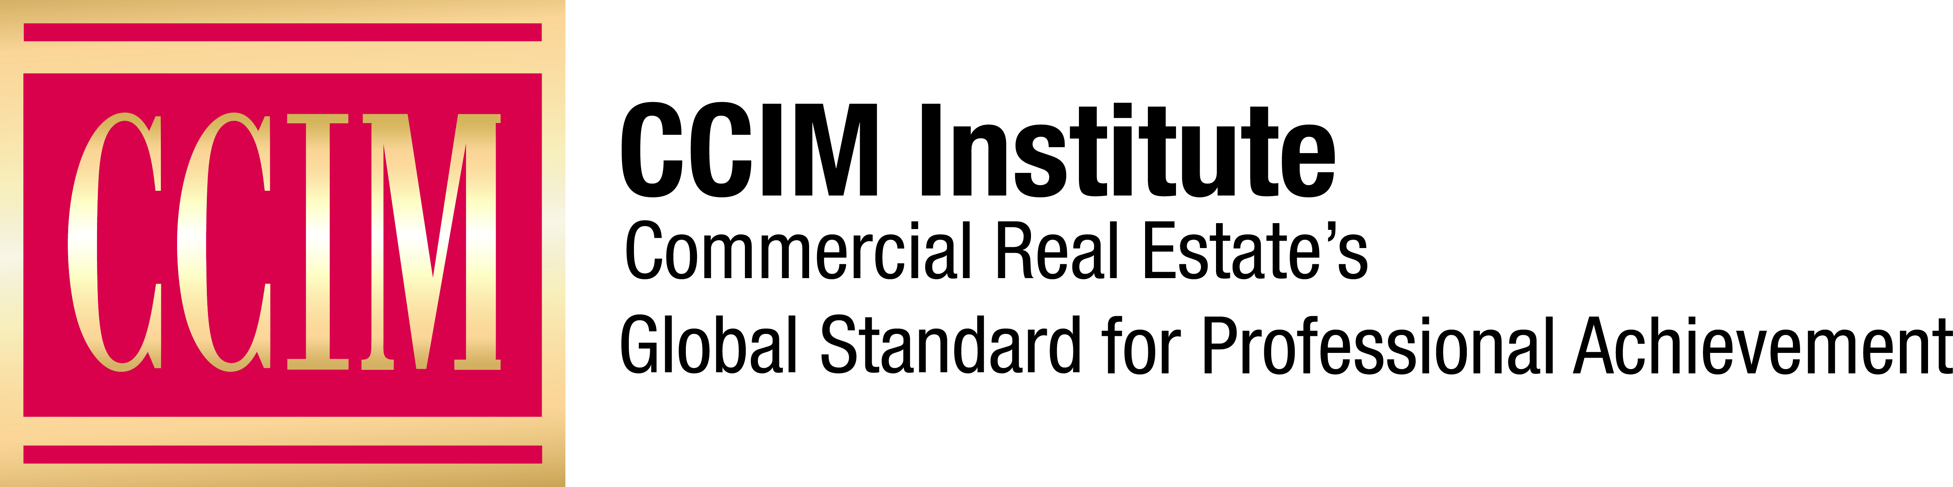

Contact: [Name of Contact] at [Phone number] or [email address]

[Local Commercial Real Estate Professional Honored at [Year] CCIM Awards Event]

[City], [Date] – More than x [include number of participants] of local commercial real estate professionals honored [number of honorees] of their accomplished peers on [date] at the [name of chapter]. CCIM Chapter’s annual [event name] held at the [name of the hotel/facility] in [city, state].

[Include a quote from the CCIM Chapter chair of the event or CCIM Chapter President about the significance of these awards]

The [name of the chapter] CCIM [event name] recognizes, promotes, and celebrates the accomplishments of outstanding men and women who exemplify the highest degree of excellence in the commercial real estate industry in [name of state or region].

This year’s top award went to [include name of top award winner, reason for the award, and a quote from the award winner].

The [event name] event began [x number of] years ago, [some history about the award and its purpose.]

This year the [name of chapter] CCIM Chapter’s leadership committee [include some news about the committee, for example, that its membership grew, its budget expanded, and/or the Excellence Awards attendance increased].

The event is designed to provide professional networking opportunities for all those involved in preparing for and attending the [event name], including committee members, finalists, CCIM members, and sponsors. [add if true] Additionally, enough funds were raised from the ceremony this year to create scholarships and funding for additional CCIM [list funded programs].

CCIM Institute is a global community of 13,000 members, more than 50 chapters, and 30 countries that educates and connects the world’s leading experts in investment strategy, financial analysis, and market analysis.

Learn more about CCIM Institute’s education and designation program at ccim.com.

###

About CCIM Institute
CCIM Institute created the language of global real estate investment. Our courses and worldwide community deploy commercial real estate investment methodologies and tools that speed the pathway between opportunity, a go/no-go decision and success for an asset, taught by instructors who are themselves industry leaders. Today, the organization, through its 50 chapters, continues to innovate best practices and elevate the commercial real estate professional through its core designation program to earn the CCIM pin— real estate’s most coveted credential — and its topical education courses offered through the Ward Center for Real Estate Studies. In addition, membership in CCIM includes the industry’s best technology and operational platform, allowing entrepreneurial and mid-sized businesses to compete with the largest multinational providers. Today, almost 70 percent of designees hold the title of owner, partner, principal, or president, representing an exclusive worldwide referral network of 13,000 members in 30 countries. Ultimately, CCIM represents a larger vision of the commercial real estate provider, leveraging investment analysis, opinions of value, and underwriting to become a leader in sourcing capital, building a cash-flow vehicle, and ultimately creating value. Information at www.ccim.com.

