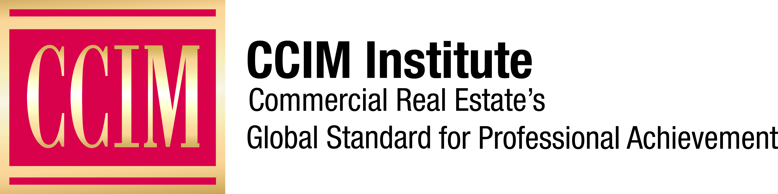

Contact: [Name of Chapter Contact] at [Phone number] or [Email address]

<name of chapter> CCIM Chapter Announces <insert year> Board of Directors

<insert name>, CCIM, to lead the organization

[City], [Date] — The <name of chapter> Chapter of CCIM Institute, one of the largest commercial real estate networks in the world with chapters in more than 30 global markets, announced its <insert year> board of directors at the organization's <insert event name> in <insert location> on <insert date>. CCIM Institute confers the Certified Commercial Investment Member designation, commercial real estate's global standard for professional achievement.

<detail each new member of the BOD> EXAMPLES: Barbara M. Crane, CCIM, 2018 president-elect, will serve as president of CCIM Institute, starting on Jan. 1, 2019. Crane is a commercial real estate broker and consultant in San Antonio. She is a senior instructor for CCIM Institute, teaching courses since 2005. Crane participated in the delivery of the CCIM Advanced Negotiation Workshop to the U.S. Department of State in Washington, D.C., and was named the Robert L. Ward Instructor of the Year in 2010. She earned her CCIM designation in 1999.

Eddie Blanton, CCIM, 2018 first vice president, assumes the role of CCIM Institute president-elect in 2018. He is principal and senior adviser with Tradd Commercial's Charlotte, N.C., office. A graduate of the Jay W. Levine Leadership Development Academy, Blanton’s service with the institute spans nearly 15 years and encompasses a variety of roles across numerous committees, including Member Services, Legislative Affairs, Strategic Planning, Finance, and Governance. Blanton also has served on the institute’s national board of directors, as well as the board of CCIM Technologies. He began his commercial real estate career in 1996 and earned his CCIM designation in 2001.

Newly elected 2019 First Vice President Timothy S. Blair, CCIM, is partner with Shannon Waltchack in Birmingham, Ala. Blair’s long history of leadership with CCIM Institute includes serving in various capacities on a wide range of committees, including Finance, Marketing, Members Services, Strategic Planning, and Designation. He also is the current secretary of the CCIM Foundation. He began his commercial real estate career more than 20 years ago and obtained his CCIM designation in 2006.

Chuck C. Connely IV, CCIM, managing director of the Lewis White Real Estate Center at the University of Missouri-Kansas and president of C.C. Connely & Associates in Kansas City, Mo., was elected to serve as CCIM Institute's 2019 treasurer. He also is a graduate of the Jay W. Levine Leadership Development Academy and has served on the CCIM Institute Board of Directors for more than 10 years. This term as treasurer will be his fifth. Connely has more than 25 years of investment banking and real estate experience. He earned his CCIM designation in 2003.

Les Callahan III, CCIM, president of First Colony Financial Corporation in Atlanta, was elected to serve as CCIM Institute's 2019 treasurer-elect. He earned his CCIM designation in 1979 and served as the 2008 president of the Georgia CCIM Chapter and has served CCIM Institute as a member of the Designation Committee, 2018 chair of the Finance Committee, and as 2014 chairman and 2015 presidential liaison for the Member Services Committee.

<if you only have a few new individuals added to the existing board, please add the following section> The full <insert year> board of directors includes: <insert names, professional titles and companies. EXAMPLE: William Adams, CCIM, president at Adams REALTORS in Atlanta; Keith Andrews, CCIM, CEO at SperryCommercial Global Affiliates - The Andrews Group in Birmingham, Ala.; Sandy Benak, CCIM, director of corporate marketing at Granite Properties in Houston; Lydia Bennett, CCIM, principal at CRE West Coast LLC and broker at Saratoga Commercial Real Estate in Bellingham, Wash.; Robin Civish, CCIM, executive vice president at ROI Real Estate in Las Vegas; Andie Edmonds, CCIM, managing partner and principal broker at NAI Cascade Commercial in Bend, Ore.; David Ellermann, CCIM, managing broker and owner at SperryCGA - Ellermann Brokerage in Chicago; Mark Hinkins, CCIM, president and managing broker at Sperry Commercial Real Estate in Walnut Creek, Calif.; Beverly Keith, CCIM principal at Commercial Properties Development Company in Raleigh, N.C.; Glynnis Fisher Levitt, CCIM, commercial real estate CRA at BBVA Compass in Birmingham, Ala.; Walter Lui, CCIM, branch manager for Century 21 Leading Edge Realty in Toronto; Bobbie Mastracci, CCIM, designated broker/principal of sales and leasing at Phoenix West Commercial, L.L.C. in Phoenix; James Robertson, CCIM, senior commercial associate broker at Realty Executives Tucson Elite in Tucson, Ariz.; David Schnitzer, CCIM, partner at ASCEND Commercial Real Estate in Dallas; Brad Waken, CCIM, owner at Waken and Company in Enid, Okla.; and Evelyn Ward, CCIM, vice president at Transwestern in Houston.>

CCIM Institute is a global community of 13,000 members, more than 50 chapters, and 30 countries that educates and connects the world’s leading experts in investment strategy, financial analysis, and market analysis.

###

<insert chapter boilerplate if you have one otherwise use the following>

About CCIM Institute
CCIM Institute created the language of global real estate investment. Our courses and worldwide community deploy commercial real estate investment methodologies and tools that speed the pathway between opportunity, a go/no-go decision and success for an asset, taught by instructors who are themselves industry leaders. Today, the organization, through its 50 chapters, continues to innovate best practices and elevate the commercial real estate professional through its core designation program to earn the CCIM pin— real estate’s most coveted credential — and its topical education courses offered through the Ward Center for Real Estate Studies. In addition, membership in CCIM includes the industry’s best technology and operational platform, allowing entrepreneurial and mid-sized businesses to compete with the largest multinational providers. Today, almost 70 percent of designees hold the title of owner, partner, principal, or president, representing an exclusive worldwide referral network of 13,000 members in 30 countries. Ultimately, CCIM represents a larger vision of the commercial real estate provider, leveraging investment analysis, opinions of value, and underwriting to become a leader in sourcing capital, building a cash-flow vehicle, and ultimately creating value. Information at www.ccim.com.

