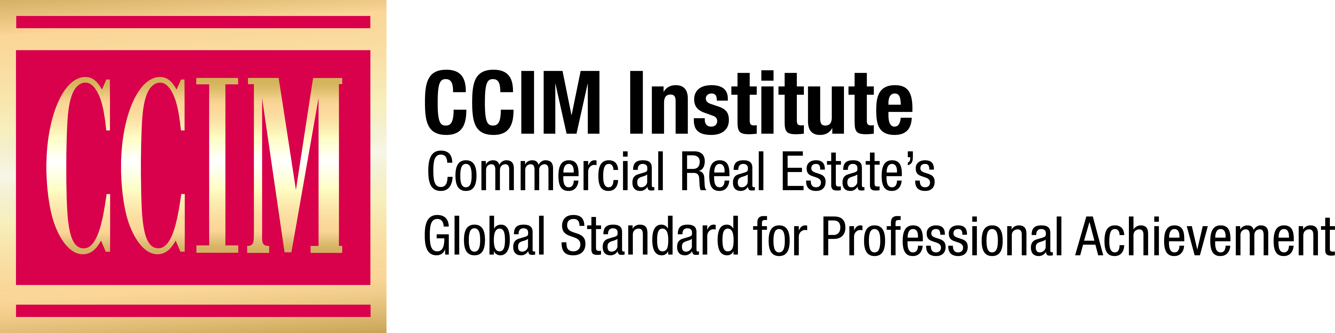

Contact: [Name of Contact] at [Phone number] or [email address]

[Chapter Name] Announces New [Year] Officers

[Your City], [Date] — [Chapter Name] of CCIM Institute is pleased to announce its new leadership team for [Year].

[Name of new president, CCIM, job title, company, city] will serve as the [Year] President of the [Chapter Name] starting on [Date]. [Add a short sentence about his/her professional experience and previous chapter leadership experience. Also insert a quote from chapter president about his/her goals for 2018.]

Other [Chapter Name] officers for the coming year include:

[List officers:
Vice President: name, CCIM, company
Treasurer: name, CCIM, company etc.]

The [Chapter Name] is one of more than 50 CCIM Institute chapters created to improve benefits to CCIM members and increase their involvement in the organization’s networking and comprehensive education for commercial real estate professionals, as well as legislative, national, and global activities. The [chapter name] encompasses [areas where members reside] and includes [number of] members.

CCIM Institute is a global community of 13,000 members in 30 countries that educates and connects the world’s leading experts in investment strategy, financial analysis, and market analysis.

Learn more about CCIM Institute’s education and designation program at ccim.com.

###

About CCIM Institute
CCIM Institute created the language of global real estate investment. Our courses and worldwide community deploy commercial real estate investment methodologies and tools that speed the pathway between opportunity, a go/no-go decision and success for an asset, taught by instructors who are themselves industry leaders. Today, the organization, through its 50 chapters, continues to innovate best practices and elevate the commercial real estate professional through its core designation program to earn the CCIM pin— real estate’s most coveted credential — and its topical education courses offered through the Ward Center for Real Estate Studies. In addition, membership in CCIM includes the industry’s best technology and operational platform, allowing entrepreneurial and mid-sized businesses to compete with the largest multinational providers. Today, almost 70 percent of designees hold the title of owner, partner, principal, or president, representing an exclusive worldwide referral network of 13,000 members in 30 countries. Ultimately, CCIM represents a larger vision of the commercial real estate provider, leveraging investment analysis, opinions of value, and underwriting to become a leader in sourcing capital, building a cash-flow vehicle, and ultimately creating value. Information at www.ccim.com.

