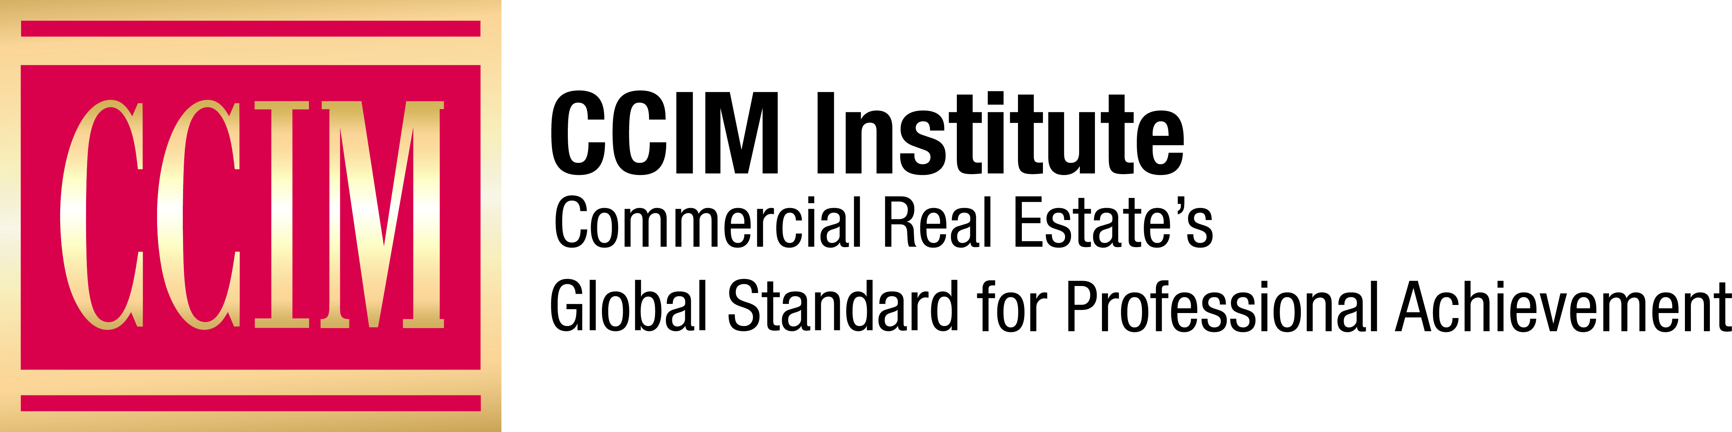

SAMPLE PRESS RELEASE FOR NEW CCIM DESIGNEES

Contact: [Name of Chapter Contact] at [Phone number] or [Email address]

FOR IMMEDIATE RELEASE

<Your Full Name> Awarded CCIM Designation Aug. <Date> in <city>

<Your last name> among 133 individuals who earned commercial real estate's global standard for professional achievement.

NAME OF CITY, STATE, (Date) – (Your Name, CCIM), (title, company, city), recently received the Certified Commercial Investment Member (CCIM) designation by the CCIM Institute. The designation was awarded during this year’s fall CCIM Comprehensive Exam testing session, which was held across 14 locations in the United States.

<Your last name> was among the 133 commercial real estate professionals who earned the designation by passing the CCIM Institute’s comprehensive examination, the capstone element in the designation process. This new group of CCIM designees hails from 37 U.S. states, as well as Canada.

“These new CCIM designees are the personification of perseverance, discipline, and drive,” says Eddie D. Blanton, CCIM, 2020 global president of CCIM Institute. “In spite of the many curveballs thrown their way, they completed their path to the pin and earned the coveted CCIM designation. That designation and access to the institute’s global CCIM community will go a long way toward ensuring their success in 2021 and for many years to come.”

<OPTIONAL: Add quote from new CCIM designee about the value of obtaining the CCIM designation and why the individual decided to earn it.>

To earn the CCIM designation, commercial real estate professionals must complete more than 160 hours of case-study-driven education covering topics such as interest-based negotiation, financial analysis, market analysis, user decision analysis, investment analysis, and ethics in commercial investment real estate. Candidates must also compile a portfolio demonstrating the depth of their commercial real estate experience and pass a comprehensive examination.

<For community newspapers, add the new CCIM’s other professional achievements, memberships, including CCIM Chapter membership, etc.>

Learn more about CCIM Institute’s education and designation program at ccim.com.

###

About CCIM Institute
CCIM Institute created the language of global real estate investment. Our courses and worldwide community deploy commercial real estate investment methodologies and tools that speed the pathway between opportunity, a go/no-go decision, and success for an asset, taught by instructors who are themselves industry leaders. Today, the organization, through its 50-plus chapters, continues to innovate best practices and elevate the commercial real estate professional through its core designation program to earn the CCIM pin — real estate’s most coveted credential — and its topical education courses offered through the Ward Center for Real Estate Studies. In addition, membership in CCIM includes the industry’s best technology and operational platform, allowing entrepreneurial and mid-sized businesses to compete with the largest multinational providers. Today, almost 70 percent of designees hold the title of owner, partner, principal, or president, representing an exclusive worldwide referral network of 13,000 members in 30 countries. Ultimately, CCIM represents a larger vision of the commercial real estate provider, leveraging investment analysis, opinions of value, and underwriting to become a leader in sourcing capital, building a cash-flow vehicle, and ultimately creating value. Information at www.ccim.com.

