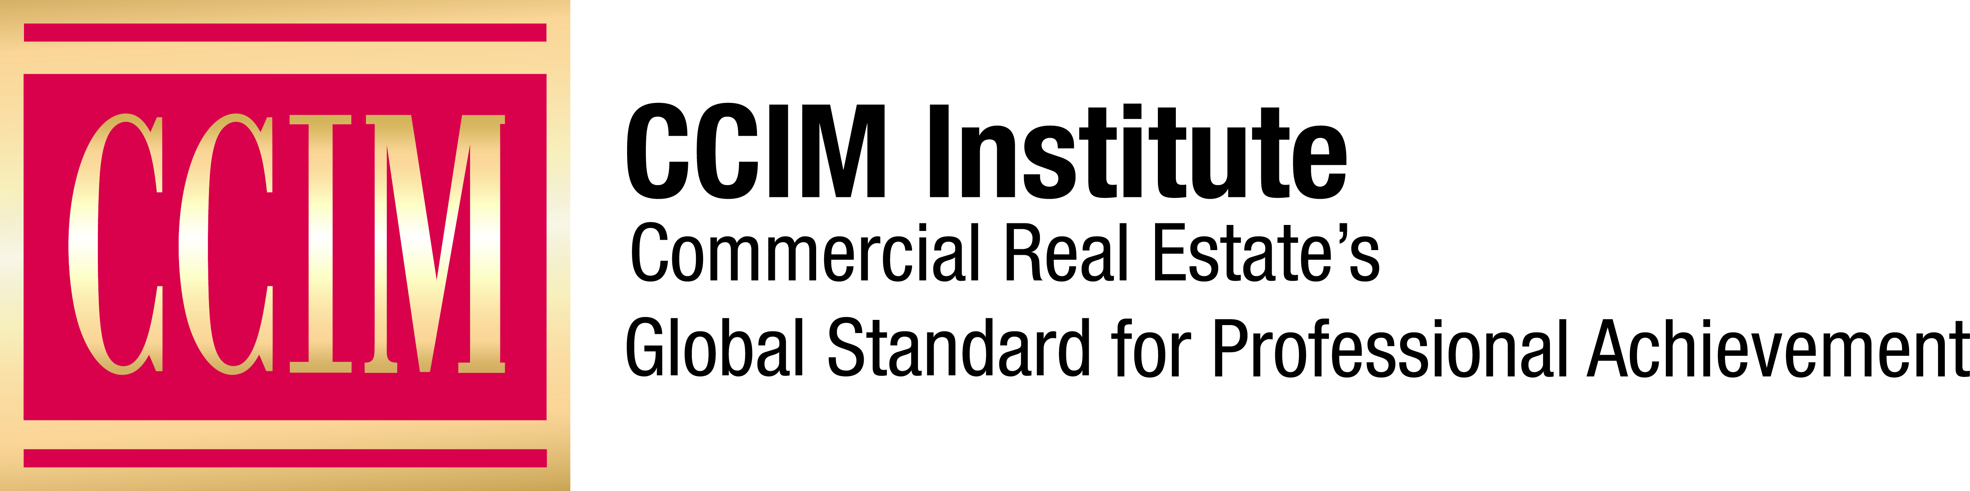

Contact: [Name of Chapter Contact] at [Phone number] or [Email address]

[City] CRE Professional Elected President of [Name of Chapter] CCIM Chapter

The CCIM designation signifies expertise in the commercial real estate profession.

[City], [Date], 2018 — [Full name], CCIM, [title and name of company] has been elected [year] President of the [chapter name] CCIM Chapter of CCIM Institute.

[Insert background information, i.e., years in real estate, specialization, other professional affiliations, awards, and any ties to local community organizations, etc.]

[Add quote from new CCIM chapter president about the leadership of this chapter locally and statewide, as well as the value of its ties to CCIM Institute.]

The [chapter name] CCIM Chapter [year] slate of officers also includes: [list name of each officer, officer title for the chapter, and his/her title and company].

The [chapter name] CCIM Chapter is one of more than 50 CCIM chapters created to improve benefits to CCIM members and increase their involvement in the organization’s networking and comprehensive education for commercial real estate professionals, as well as legislative, national, and global activities. The [chapter name] CCIM Chapter encompasses [areas where members reside] and includes [number of] members.

CCIM Institute is a global community of 13,000 members in 30 countries that educates and connects the world’s leading experts in investment strategy, financial analysis, and market analysis.

###

About CCIM Institute
CCIM Institute created the language of global real estate investment. Our courses and worldwide community deploy commercial real estate investment methodologies and tools that speed the pathway between opportunity, a go/no-go decision and success for an asset, taught by instructors who are themselves industry leaders. Today, the organization, through its 50 chapters, continues to innovate best practices and elevate the commercial real estate professional through its core designation program to earn the CCIM pin— real estate’s most coveted credential — and its topical education courses offered through the Ward Center for Real Estate Studies. In addition, membership in CCIM includes the industry’s best technology and operational platform, allowing entrepreneurial and mid-sized businesses to compete with the largest multinational providers. Today, almost 70 percent of designees hold the title of owner, partner, principal, or president, representing an exclusive worldwide referral network of 13,000 members in 30 countries. Ultimately, CCIM represents a larger vision of the commercial real estate provider, leveraging investment analysis, opinions of value, and underwriting to become a leader in sourcing capital, building a cash-flow vehicle, and ultimately creating value. Information at www.ccim.com.

