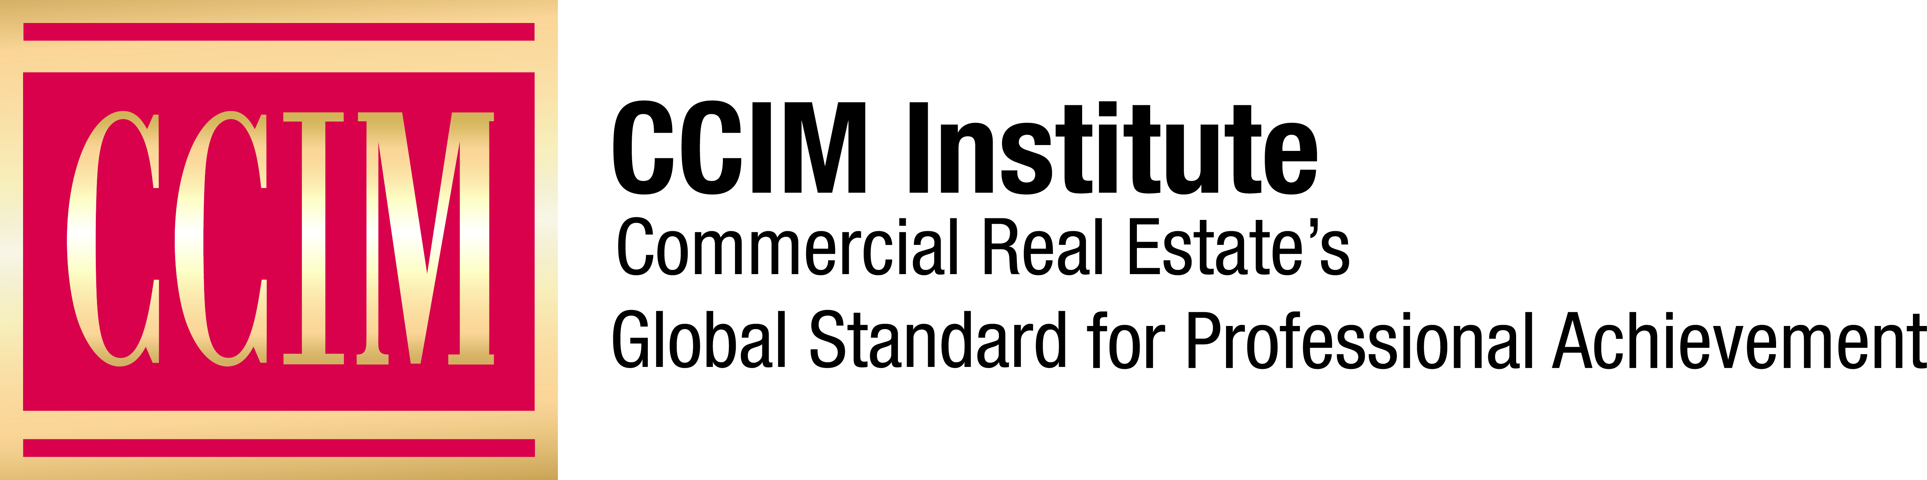

Contact: [Name of Chapter Contact] at [Phone number] or [Email address]

[Chapter name] CCIM Chapter Honors New CCIM Designees

The CCIM designation signifies expertise in the commercial real estate profession.

[City], [Date] — The [Chapter name] CCIM Chapter has recognized [Number] chapter members who recently earned the Certified Commercial Investment Member designation, the global standard for professional achievement, from the CCIM Institute. Headquartered in Chicago, CCIM Institute is one of the largest global commercial real estate networks.

The following [Chapter Name] CCIM Chapter members were among the 133 industry professionals who earned the CCIM designation during the organization’s fall CCIM Comprehensive Exam testing session, which was held across 14 locations in the United States. To ensure the safety of candidates, instructors, and exam proctors alike, current recommended safety protocols were used throughout Course Concepts Review sessions and the exam itself.

- [List names, CCIM, title, firm, city, state, for new CCIM designees]

“These new CCIM designees are the personification of perseverance, discipline, and drive,” says Eddie D. Blanton, CCIM, 2020 global president of CCIM Institute. “In spite of the many curveballs thrown their way, they completed their path to the pin and earned the coveted CCIM designation. That designation and access to the institute’s global CCIM community will go a long way toward ensuring their success in 2021 and for many years to come.”

[OPTIONAL: Add Quote from Chapter President]

To earn the CCIM designation, commercial real estate professionals must complete more than 160 hours of case-study-driven education covering topics such as interest-based negotiation, financial analysis, market analysis, user decision analysis, investment analysis, and ethics in commercial investment real estate. Candidates must also compile a portfolio demonstrating the depth of their commercial real estate experience and pass a comprehensive examination.

CCIM Institute is a global community of 13,000 members and more than 50 chapters in 30 countries that educates and connects the world’s leading experts in investment strategy, financial analysis, and market analysis.

Learn more about CCIM Institute’s education and designation program at ccim.com.

###

About CCIM Institute
CCIM Institute created the language of global real estate investment. Our courses and worldwide community deploy commercial real estate investment methodologies and tools that speed the pathway between opportunity, a go/no-go decision, and success for an asset, taught by instructors who are themselves industry leaders. Today, the organization, through its 50-plus chapters, continues to innovate best practices and elevate the commercial real estate professional through its core designation program to earn the CCIM pin — real estate’s most coveted credential — and its topical education courses offered through the Ward Center for Real Estate Studies. In addition, membership in CCIM includes the industry’s best technology and operational platform, allowing entrepreneurial and mid-sized businesses to compete with the largest multinational providers. Today, almost 70 percent of designees hold the title of owner, partner, principal, or president, representing an exclusive worldwide referral network of 13,000 members in 30 countries. Ultimately, CCIM represents a larger vision of the commercial real estate provider, leveraging investment analysis, opinions of value, and underwriting to become a leader in sourcing capital, building a cash-flow vehicle, and ultimately creating value. Information at www.ccim.com.

