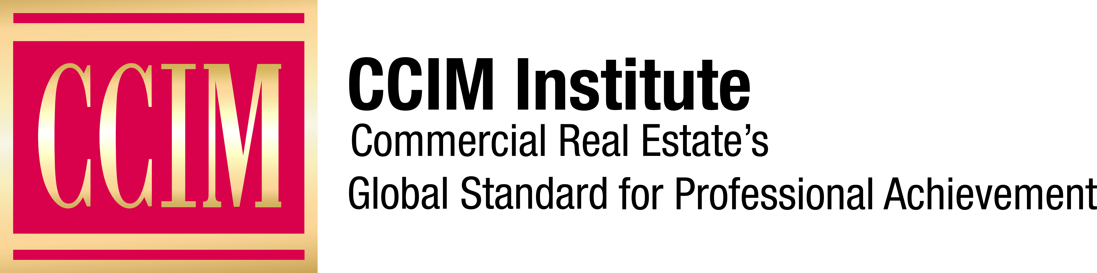

Contact: [Name of Chapter Contact] at [Phone number] or [Email address]

[Chapter Name] CCIM Chapter Honors Charter Members

The CCIM designation signifies expertise in the commercial real estate profession.

[City], [Date], 2018 — The [Name] CCIM Chapter will honor [Number] of its members who are charter members of CCIM Institute. CCIM Institute is one of the largest global commercial real estate networks.

The following [Chapter Name] CCIM Chapter members will be recognized for their longstanding commitment to CCIM Institute at a presentation ceremony on [Date] at [Time] at [Location]:

• [List names, CCIM, title, firm, city, state, for honorees]

[Insert Quote from Chapter President]

More than 315 real estate professionals were involved in the program prior to it becoming the CCIM designation in 1967. Today, there are 22 charter members throughout the U.S. who are still active CCIM Institute members. They are the foundation of a network of more than 13,000 other professionals who have earned the CCIM designation.

Learn more about CCIM Institute’s education and designation program at ccim.com.

###

About CCIM Institute
CCIM Institute created the language of global real estate investment. Our courses and worldwide community deploy commercial real estate investment methodologies and tools that speed the pathway between opportunity, a go/no-go decision and success for an asset, taught by instructors who are themselves industry leaders. Today, the organization, through its 50 chapters, continues to innovate best practices and elevate the commercial real estate professional through its core designation program to earn the CCIM pin— real estate’s most coveted credential — and its topical education courses offered through the Ward Center for Real Estate Studies. In addition, membership in CCIM includes the industry’s best technology and operational platform, allowing entrepreneurial and mid-sized businesses to compete with the largest multinational providers. Today, almost 70 percent of designees hold the title of owner, partner, principal, or president, representing an exclusive worldwide referral network of 13,000 members in 30 countries. Ultimately, CCIM represents a larger vision of the commercial real estate provider, leveraging investment analysis, opinions of value, and underwriting to become a leader in sourcing capital, building a cash-flow vehicle, and ultimately creating value. Information at www.ccim.com.

